POPULATION GROWTH ANALYSIS
AND FORECASTING USING DATA ANALYTICS
A Data Analytics Project Report
Course: Introduction to Data Analytics
Submitted by:
Pranav Sukhadev Phadtare
Abhishek Karthik Akunuru
Instructor: Dr. Sami Ur Rahman
Institution: University of Europe for Applied Sciences
Submission Date: June 21, 2026

Table of Contents
Table of Contents 2
1. Introduction 3
2. Project Objectives 3
3. Dataset Description 3
3.1 Dataset Composition 3
3.2 Data Source and References 4
4. Data Cleaning and Preprocessing 4
5. Methodology 4
6. Analysis and Findings 5
6.1 Basic Analysis 5
Top 10 Most Populated Countries (2024) 5
Bottom 10 Least Populated Countries / Territories (2024) 6
Population Distribution 7
6.2 Growth Analysis 7
Top 10 Countries by Average Growth Rate 7
Average Growth Rate by Continent 8
Countries with Negative Population Growth 9
Growth Extremes 10
6.3 Comparative Analysis 10
7. Advanced Analysis 11
7.1 Outliers in Population Growth 11
7.2 Long-Term Growth Ranking 12
7.3 Population Doubling Time 13
7.4 Population Size vs. Growth Rate Relationship 13
7.5 Growth Rate Patterns Over Time (Heatmap) 14
8. Prediction and Forecasting 15
Forecasted Population for India (2025–2034) 15
8.1 Limitations of the Prediction Model 15
9. Interpretation of Key Insights 16
10. Limitations of the Analysis 16
11. Conclusion 17
12. References 17

1. Introduction
Few statistics touch daily life as broadly as population does. How many people live somewhere, and how fast that number is changing, ends up shaping hospital capacity, school enrollment, housing demand, traffic, food supply, and a long list of other things most people never think about until they become a problem. That is really the starting point for this project: to take an honest, data-driven look at how the world's population has changed since 1960, and to see what the numbers actually show rather than what is commonly assumed.
The analysis is built on a 65-year global dataset covering nearly 200 countries. It moves through the usual stages of a data analytics project — cleaning the raw figures, exploring what they reveal, digging into a handful of more advanced questions, visualizing the patterns that emerge, and finally attempting a short-term forecast. The aim throughout was to let the data speak for itself.

2. Project Objectives
Specifically, this project set out to:
- Pull together a reliable, multi-decade population dataset covering as many countries as possible.
- Clean up the raw data — missing values, duplicate rows, inconsistent country names — so it could actually be trusted for analysis.
- Explore the data for basic patterns: who is growing, who isn't, and how the continents compare to one another.
- Go a layer deeper with a few advanced techniques, including outlier detection, long-term growth ranking, and doubling-time estimates.
- Turn the key findings into charts that are genuinely easy to read, not just technically accurate.
- Build a simple forecast for one country's population and be upfront about where that forecast could go wrong.

3. Dataset Description
For this project we used the World Bank's “Population, total” indicator (SP.POP.TOTL). It reports the de facto population of countries and territories around the world — essentially everyone physically residing there at the time, regardless of legal status or citizenship.

3.1 Dataset Composition
- Coverage: 198 countries and territories
- Time span: 65 years (1960–2024) — more than double the 30-year minimum the project called for
- Granularity: one population figure per country, per year
- Additional field: a Continent / region category for every country, which made the comparative analysis possible
- Final cleaned size: 12,870 country-year records across 8 analytical columns (Country, Continent, Year, Population, Annual Change, Growth Rate %, Decade, Growth Category)

3.2 Data Source and References
Primary source: World Bank Open Data — Population, total (SP.POP.TOTL).
Dataset link: https://data.worldbank.org/indicator/SP.POP.TOTL
We also referred to the accompanying World Bank metadata files (Metadata_Country and Metadata_Indicator) to confirm country groupings, income classifications, and the exact definition of the indicator itself.

4. Data Cleaning and Preprocessing
The raw World Bank export comes in “wide” format — one row per country, one column per year — which isn't very useful for the kind of time-series analysis this project needed. A Python script (using pandas) reshaped it into a proper “long” format and, along the way, fixed a handful of data quality issues. In order, the steps were:
- Dropped identifier columns that weren't needed for analysis (Country Code, Indicator Name, Indicator Code).
- Reshaped the data from wide to long format with pandas' melt(), keeping Country and Continent as identifiers and turning each year-column into a Year/Population pair.
- Converted the Population field to numeric, stripping out thousands-separator commas and letting invalid entries become missing values (NaN) rather than silently breaking the column.
- Converted Year to an integer type.
- Dropped any record still missing a Country, Year, or Population value after the above steps.
- Removed duplicate rows.
- Cleaned up country-name formatting (trimmed whitespace, title case) and fixed common abbreviations — USA became United States, UK became United Kingdom, UAE became United Arab Emirates.
- Sorted everything by Country and then Year, which the later time-series calculations depend on.
- Added four new columns: Annual Change (year-over-year difference), Growth Rate % (year-over-year percentage change), Decade (year rounded down to the nearest 10), and Growth Category (Negative / Low / Medium / High, based on growth-rate thresholds).
What came out the other end is a clean dataset of 12,870 country-year records with no missing values in any of the core fields, saved as Cleaned_Population_Data.csv.

5. Methodology
All of the analysis was done in Python. The main tools were:
- pandas — for loading, cleaning, reshaping, and aggregating the data
- NumPy — for the numerical operations behind the statistical calculations
- Matplotlib and Seaborn — for the charts (line, bar, pie, scatter, heatmap, histogram)
- scikit-learn — specifically its linear regression model, for the forecast
The work happened roughly in five stages: collecting and cleaning the data, exploring population levels and growth rates, running a few advanced statistical checks (outlier detection via the interquartile range method and a long-term growth ranking among them), visualizing what came out of all that, and finally forecasting ten years past the dataset's final year using an ordinary least-squares linear regression.

6. Analysis and Findings

6.1 Basic Analysis
Global population went from roughly 2.95 billion in 1960 to about 7.84 billion in 2024 — an increase of around 4.89 billion people, or about 166%, in 65 years.
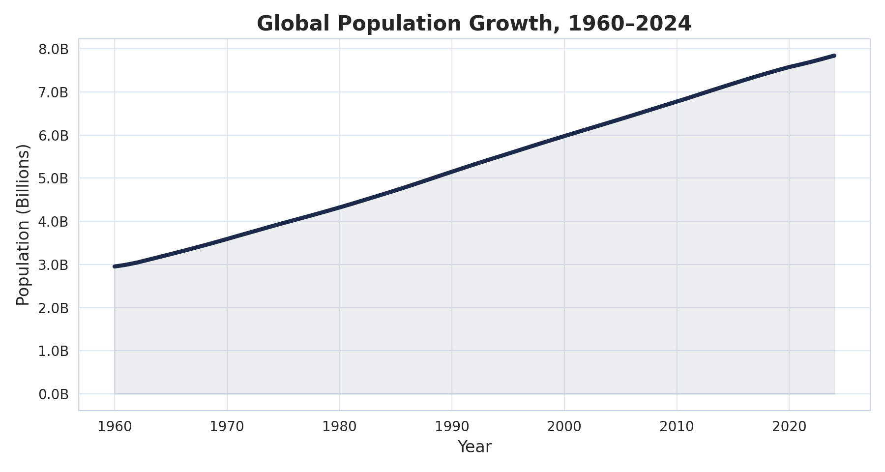
Figure 1. Global population has risen every year since 1960, though the curve isn't quite as steep as it used to be — the rate of increase has been slowing since the late 20th century.
India is now the most populated country in the dataset, with 1,450,935,791 people in 2024, just ahead of China at 1,408,975,000. It's a fairly recent change — India overtook China as the world's most populous nation during the later years covered by this dataset. At the other end of the scale, the smallest population on record is Nauru's 4,607 residents in 1960.

Top 10 Most Populated Countries (2024)
Country | Population (2024)
India | 1,450,935,791
China | 1,408,975,000
United States | 340,110,988
Indonesia | 283,487,931
Pakistan | 251,269,164
Nigeria | 232,679,478
Brazil | 211,998,573
Bangladesh | 173,562,364
Russian Federation | 143,533,851
Ethiopia | 132,059,767

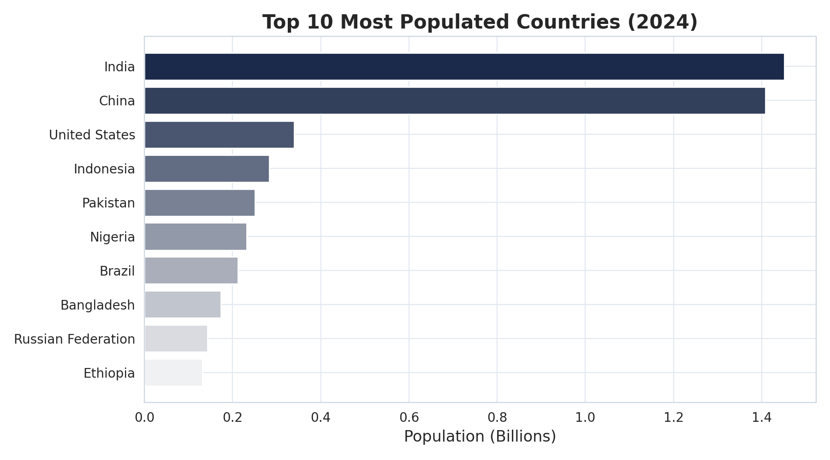
Figure 2. India and China together account for roughly 36% of the world's population.

Bottom 10 Least Populated Countries / Territories (2024)
Country / Territory | Population (2024)
Tuvalu | 9,646
Nauru | 11,947
Palau | 17,695
San Marino | 33,977
Marshall Islands | 37,548
Monaco | 38,631
Gibraltar | 39,329
British Virgin Islands | 39,471
Liechtenstein | 40,450
Northern Mariana Islands | 44,278

Unsurprisingly, the bottom 10 are mostly small island nations and micro-territories — every one of them has fewer than 45,000 residents.

Population Distribution
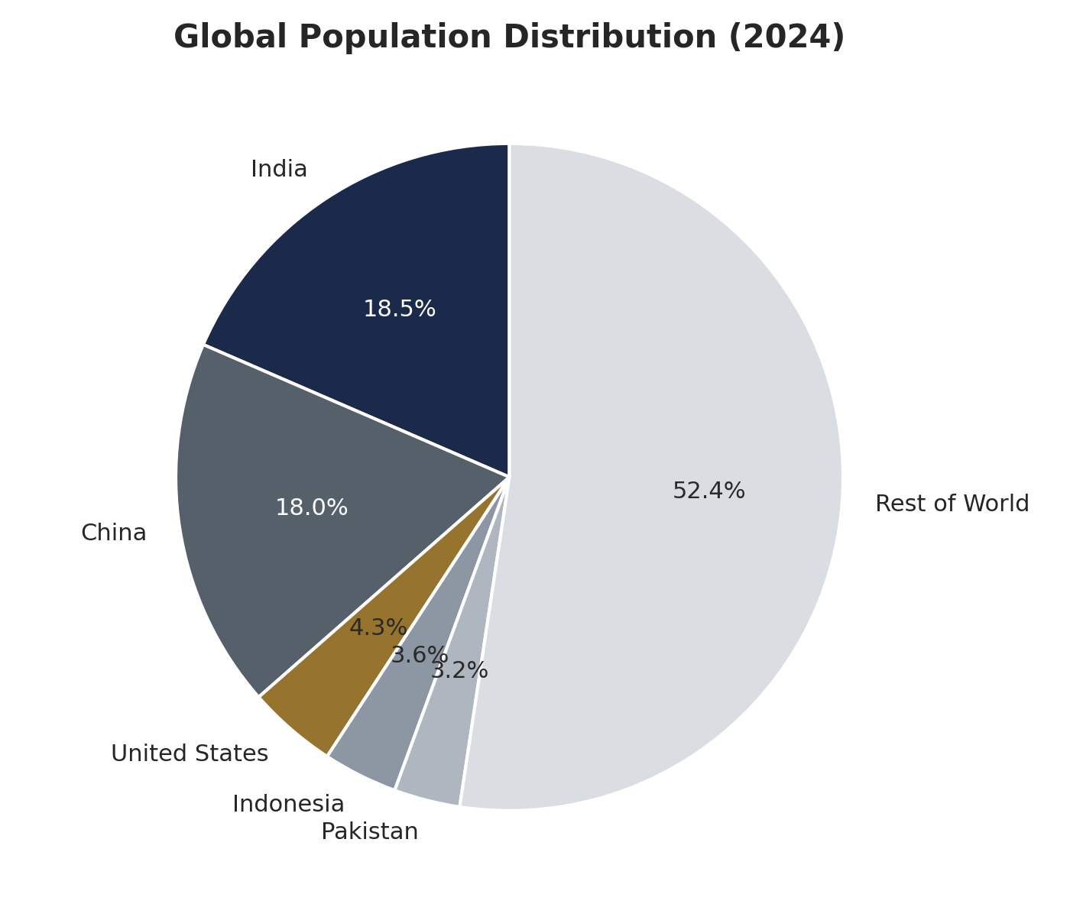
Figure 3. India and China alone make up over a third of the global population. Add in the next three biggest countries and the top five account for nearly half (47.6%) of everyone alive — leaving just over half of humanity spread across the remaining 193 countries and territories.

6.2 Growth Analysis
We calculated the average annual growth rate for every country across the full study period. The fastest growers, on average, turn out to be concentrated in the Gulf region — and that's mostly about labor migration, not births. It's worth keeping that distinction in mind when reading the next table.

Top 10 Countries by Average Growth Rate
Country | Average Growth Rate (%)
United Arab Emirates | 7.13
Qatar | 7.09
Kuwait | 4.51
Saudi Arabia | 4.22
Djibouti | 4.14
Jordan | 4.11
Oman | 3.63
Bahrain | 3.57
Andorra | 3.42
Cayman Islands | 3.42

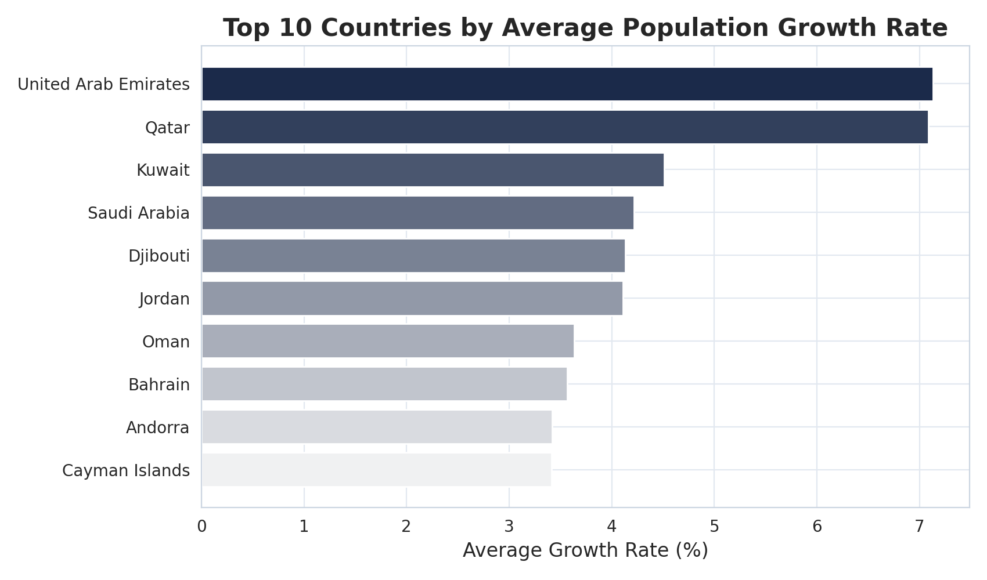
Figure 4. The United Arab Emirates and Qatar lead average annual growth, both above 7% per year — well ahead of the global average.

Average Growth Rate by Continent
Continent | Average Growth Rate (%)
Africa | 2.46
Asia | 2.33
Oceania | 1.63
South America | 1.54
North America | 1.46
Europe | 0.52

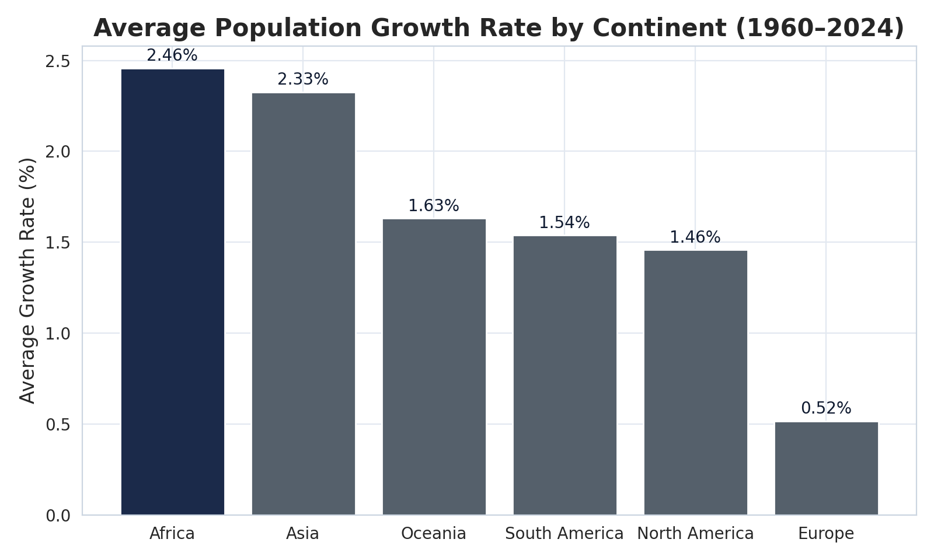
Figure 5. Africa (2.46%) and Asia (2.33%) post the highest average growth rates. Europe (0.52%) trails well behind both, which lines up with what's generally known about its aging, slow-growing population.
Eight of the 198 countries and territories in this dataset have a negative average growth rate across the full 1960–2024 stretch. A larger group dipped into negative growth for at least a year or two, usually tied to a specific shock — conflict, mass emigration, or a correction after an earlier population boom.

Countries with Negative Population Growth
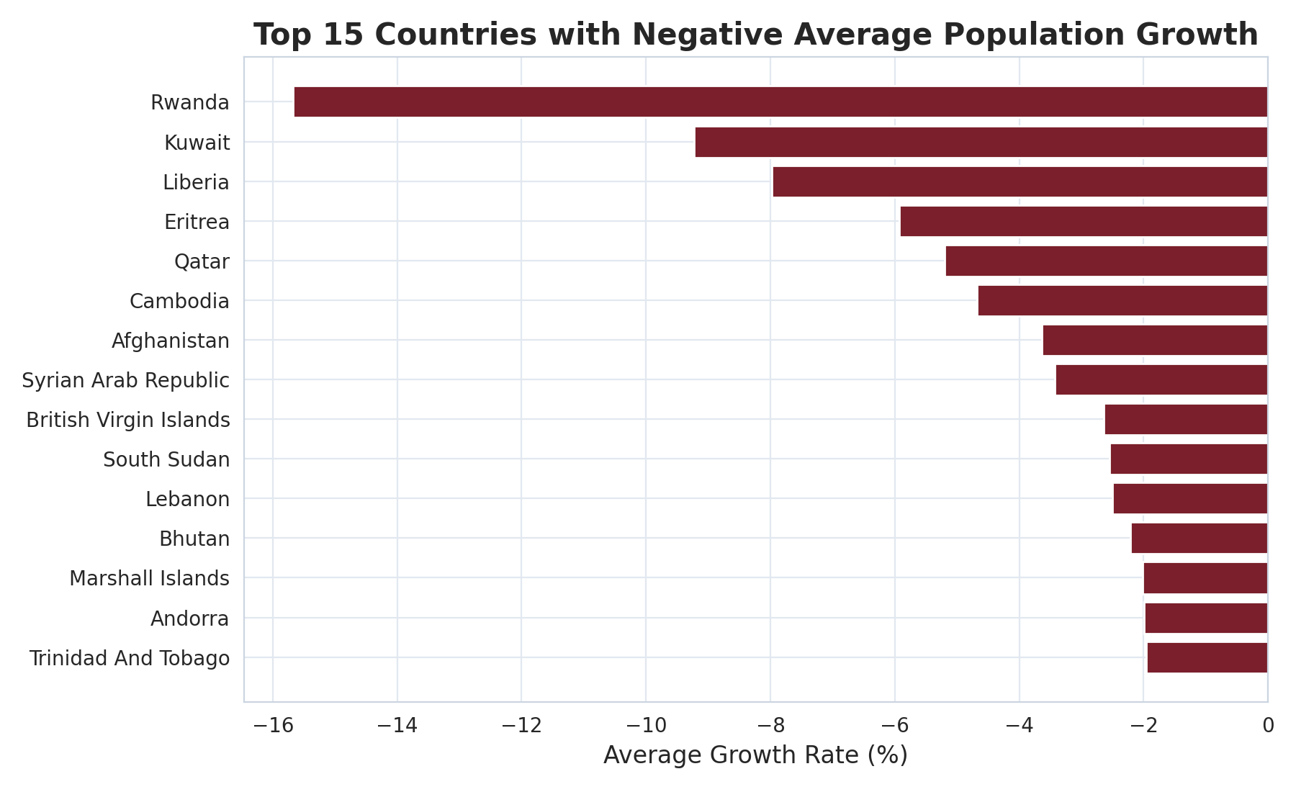
Figure 6. Rwanda's negative-growth years — tied to the 1994 genocide and its aftermath — show the steepest average decline of any country in the dataset, followed by Kuwait (the population exodus around the 1990 Gulf War) and Liberia (civil conflict).

Growth Extremes
Type | Country | Year | Growth Rate
Highest Growth | Qatar | 2007 | +24.23%
Lowest Growth | Kuwait | 1990 | -24.02%

The single highest annual growth rate anywhere in the dataset belongs to Qatar: +24.23% in 2007, driven by a wave of foreign construction and energy workers. The lowest belongs to Kuwait: -24.02% in 1990, which lines up exactly with the Gulf War and the mass displacement that followed.
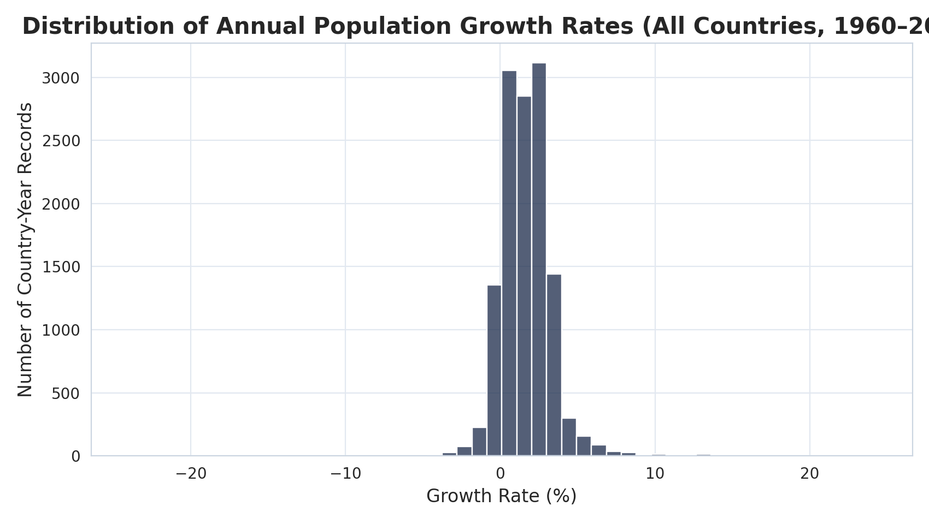
Figure 7. Most country-year growth rates fall somewhere between 0% and 4%. A small number of outliers — mostly small Gulf states and conflict-affected countries — stretch the tails out to roughly ±24%.

6.3 Comparative Analysis
We also compared five major economies directly — India, China, the United States, Germany, and Brazil — to see how different their trajectories really are. India and China dwarf the other three in sheer size, while Germany's population has barely moved since the 1990s.
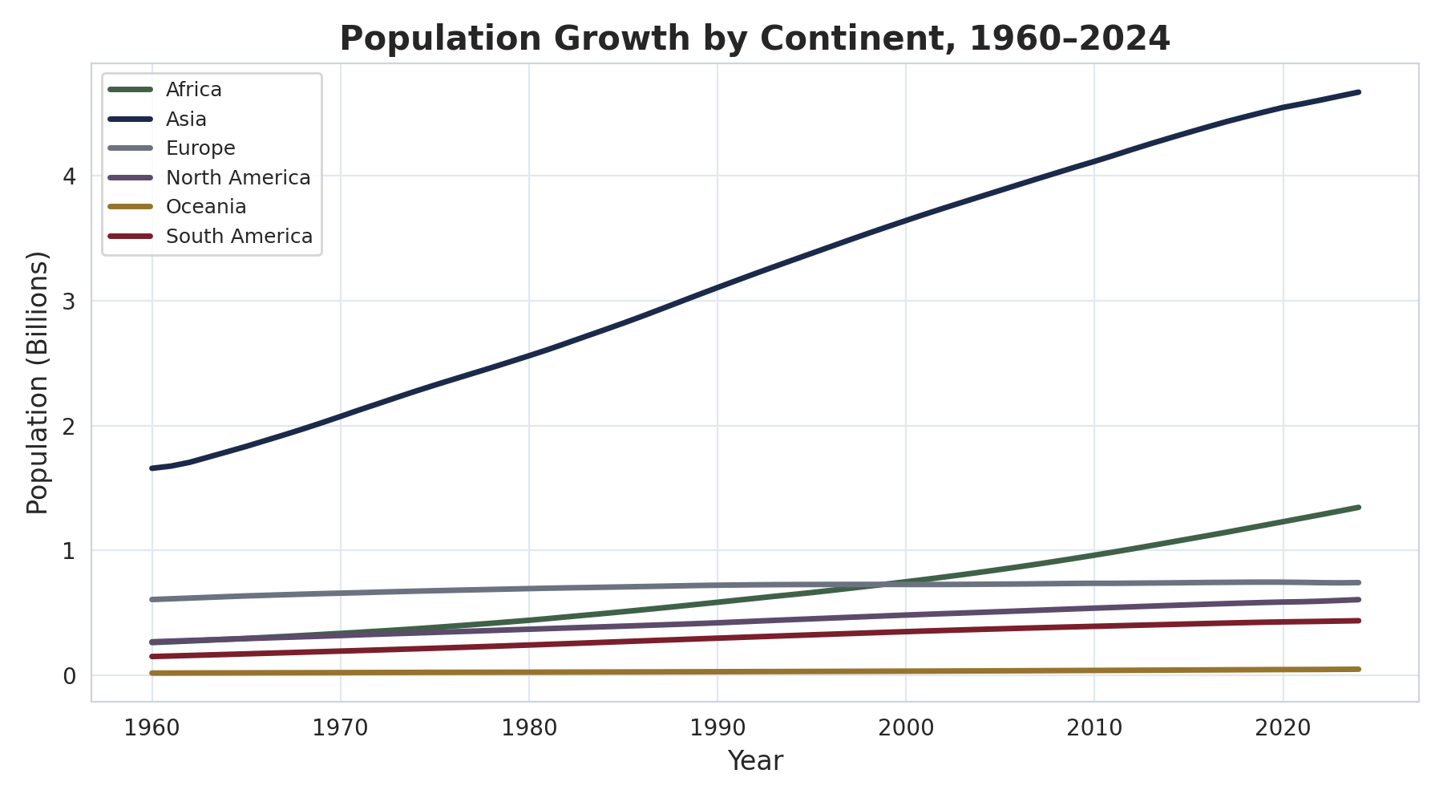
Figure 8. Asia's population dwarfs every other continent combined, but Africa is the one to watch — it shows the steepest upward trajectory of recent decades, with real implications for where the world's population will be concentrated a few decades from now.

7. Advanced Analysis
Beyond the baseline exploratory work, we ran five advanced techniques to dig a bit deeper into the data — more than the two the assignment called for.

7.1 Outliers in Population Growth
Using the interquartile range (IQR) method, we flagged country-years with growth rates well outside the typical range as statistical outliers. The table below shows the 20 most extreme cases, one per country, ranked by how far they deviate.
Country | Year | Growth Rate (%)
Qatar | 2007 | 24.23
Kuwait | 1990 | -24.02
Macao SAR, China | 1964 | 23.89
Seychelles | 2022 | 20.77
United Arab Emirates | 1969 | 20.18
Rwanda | 1996 | 18.23
Oman | 2012 | 15.29
Northern Mariana Islands | 1982 | 12.73
Afghanistan | 1993 | 12.53
Liberia | 1991 | -12.01
Djibouti | 1990 | 10.74
Lebanon | 2014 | 10.51
Jordan | 2014 | 10.01
Andorra | 1968 | 8.45
Cambodia | 1995 | 8.44
Bahrain | 2007 | 8.21
Ukraine | 2023 | -8.08
Bosnia and Herzegovina | 1993 | -7.80
Marshall Islands | 1969 | 7.27
Mozambique | 1994 | 6.99

Looking at the list, the outliers really fall into two buckets: rapid, labor-driven immigration into small, wealthy Gulf states (Qatar, the UAE, Bahrain, Oman), and sharp population shocks tied to conflict or political upheaval (Kuwait, Liberia, Rwanda, Ukraine, Bosnia and Herzegovina, Afghanistan).

7.2 Long-Term Growth Ranking
Ranking countries by total population added between 1960 and 2024 shows which nations have actually contributed the most to global population growth in raw numbers — as opposed to percentage terms.
Country | 1960 Population | 2024 Population | Total Growth | Growth %
India | 435,990,338 | 1,450,935,791 | 1,014,945,453 | 232.79%
China | 667,070,000 | 1,408,975,000 | 741,905,000 | 111.22%
Pakistan | 45,709,310 | 251,269,164 | 205,559,854 | 449.71%
Indonesia | 88,296,070 | 283,487,931 | 195,191,861 | 221.07%
Nigeria | 45,053,782 | 232,679,478 | 187,625,696 | 416.45%
United States | 180,671,000 | 340,110,988 | 159,439,988 | 88.25%
Brazil | 72,388,126 | 211,998,573 | 139,610,447 | 192.86%
Bangladesh | 51,828,660 | 173,562,364 | 121,733,704 | 234.88%
Ethiopia | 21,376,693 | 132,059,767 | 110,683,074 | 517.77%
Mexico | 36,724,615 | 130,861,007 | 94,136,392 | 256.33%

India added more than a billion people since 1960 — more than any other country by a wide margin — with China and Pakistan following behind. But percentage terms tell a different story: Ethiopia (+518%) and Pakistan (+450%) actually grew far faster proportionally than either India or China, which is a good reminder that absolute and relative growth aren't the same conversation.

7.3 Population Doubling Time
Applying the Rule of 70 (doubling time ≈ 70 ÷ annual growth rate) to the ten most populous countries gives a rough sense of how long each would take to double its population, assuming its average growth rate held steady.
Country | Avg. Growth Rate (%) | Doubling Time (Years)
Ethiopia | 2.84 | 24.62
Pakistan | 2.66 | 26.33
Nigeria | 2.56 | 27.36
Bangladesh | 1.88 | 37.24
India | 1.87 | 37.45
Indonesia | 1.81 | 38.60
Brazil | 1.67 | 41.92
China | 1.16 | 60.33
United States | 0.98 | 71.53
Russian Federation | 0.28 | 250.69

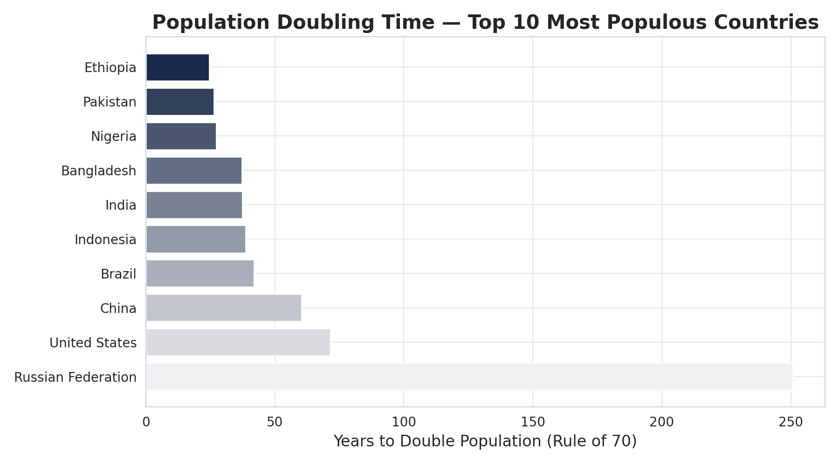
Figure 9. Ethiopia, Pakistan, and Nigeria would double their populations in roughly 25–27 years at their historical average growth rates. Russia is the opposite case — its growth is so close to flat that the implied doubling time is 250 years, which in practice just means a stable population.

7.4 Population Size vs. Growth Rate Relationship
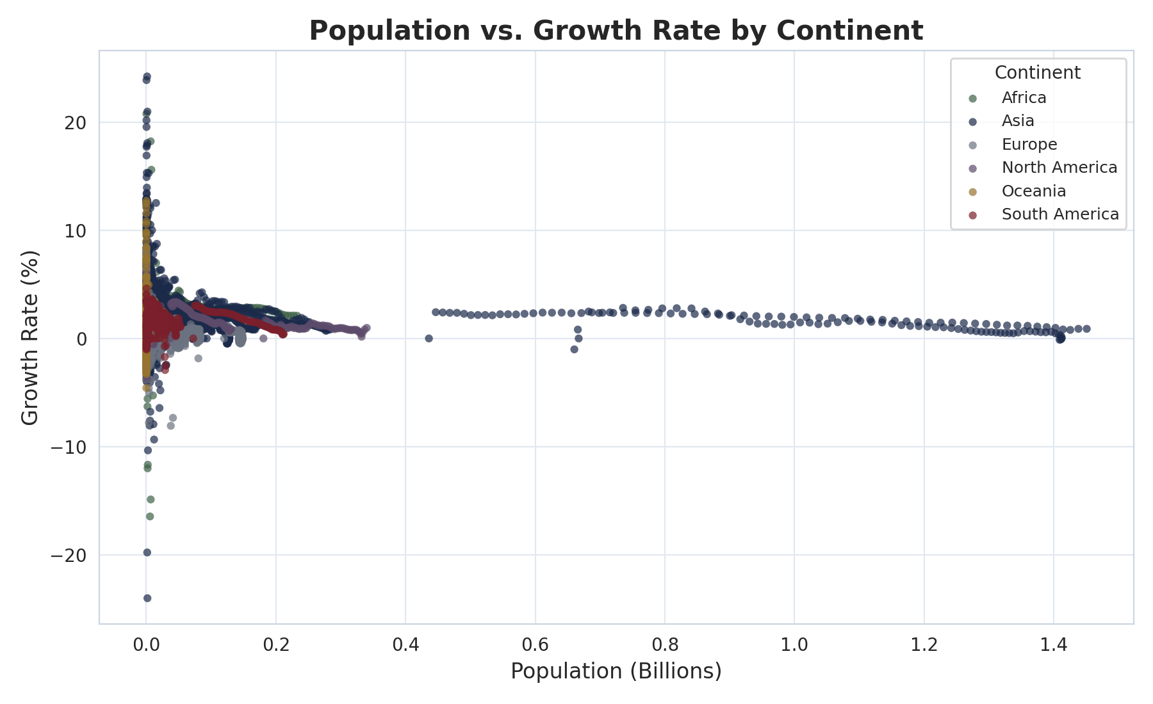
Figure 10. There's no strong relationship between how big a country's population is and how fast it's growing. The very large countries on the right side of the chart cluster around modest, stable growth, while almost all of the volatility — in either direction — shows up among small-population countries.

7.5 Growth Rate Patterns Over Time (Heatmap)
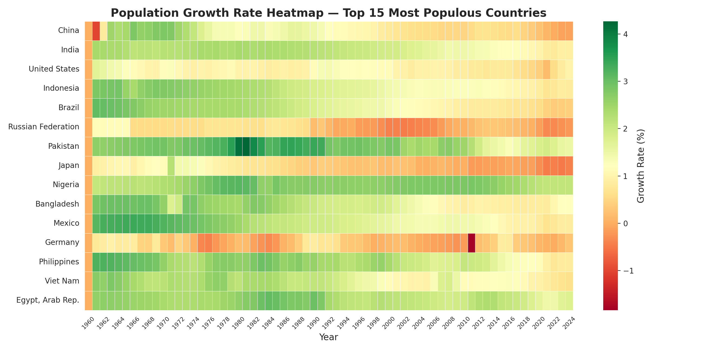
Figure 11. The heatmap is more useful for spotting long-run regimes than year-to-year noise. Nigeria and Pakistan stay green (high growth) for decades at a stretch; Germany and Japan drift slowly from green into orange and red over several decades; and Russia's growth visibly collapses right after 1990.

8. Prediction and Forecasting
We fitted a simple linear regression to India's historical population (1960–2024) and used it to project the next 10 years, 2025 through 2034. India made sense as the focus country here — it's the world's most populous nation now, and it will be a major factor in where global population heads next.

Forecasted Population for India (2025–2034)
Year | Predicted Population (Billions)
2025 | 1.48
2026 | 1.50
2027 | 1.52
2028 | 1.53
2029 | 1.55
2030 | 1.57
2031 | 1.58
2032 | 1.60
2033 | 1.62
2034 | 1.63

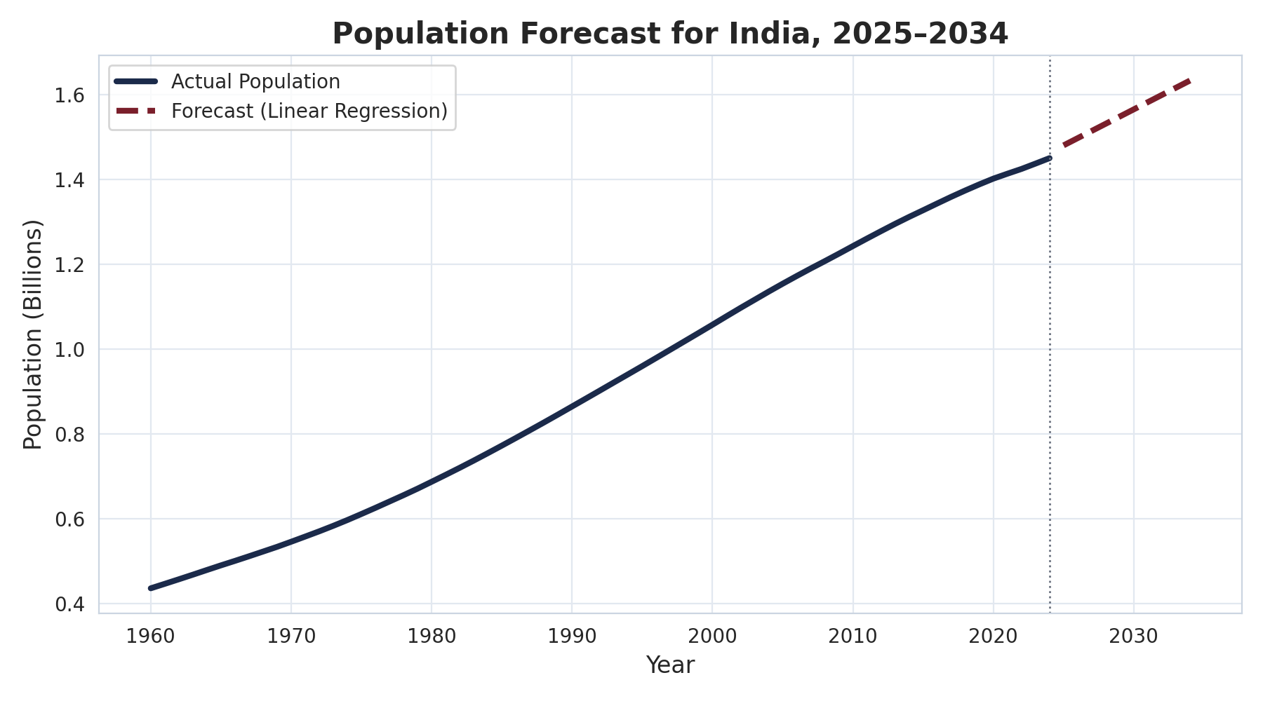
Figure 12. The linear trend projects India's population climbing from about 1.48 billion in 2025 to roughly 1.63 billion by 2034 — basically a continuation of the trajectory it's already on.

8.1 Limitations of the Prediction Model
- Linear regression assumes a constant rate of growth, which does not reflect real-world fluctuations caused by policy or social change.
- The model does not account for external factors such as migration, government population policy, war, or economic shocks.
- Forecast accuracy decreases the further into the future the prediction extends.
- Unexpected events (pandemics, conflicts, climate disasters) can sharply alter population trends in ways no historical trend can anticipate.
- Reporting standards and census methodology vary by country, so cross-country comparisons — especially for very small territories — carry some uncertainty.
- The doubling-time (Rule of 70) calculation is undefined for countries with zero or negative growth and was therefore excluded for those cases.

9. Interpretation of Key Insights
- Global population is still growing, but more slowly than it used to — the world keeps adding people, just at a gradually decreasing rate each year.
- India has overtaken China as the world's most populous country, and China's growth rate has fallen close to zero. That's a real demographic turning point for Asia, not just a statistical footnote.
- Africa now has the highest average growth rate of any continent, at 2.46% — which means its share of global population will likely keep rising over the coming decades.
- Europe sits at the opposite end, with the lowest continental growth rate (0.52%), in line with the well-known aging-population and low-fertility trends in countries like Germany and Japan.
- The biggest growth swings, in either direction, show up in small, economically specialized countries (migrant-driven Gulf-state booms) or countries in conflict (Kuwait, Rwanda, Liberia, Ukraine). Larger countries, by comparison, are remarkably stable.
- Absolute and relative growth really are different stories. India and China lead in raw numbers added, but smaller, lower-income countries like Ethiopia and Pakistan are growing much faster proportionally — and will likely make up a bigger share of the world's population as time goes on.

10. Limitations of the Analysis
- The forecast leans on a simple linear model, which can't capture non-linear demographic shifts — declining fertility as a country develops, for instance — that real populations actually go through.
- We only forecast one country in detail. Other major countries (China's near-zero growth or Nigeria's high growth, say) would be worth the same treatment, but that was outside what this project could cover.
- Country borders, names, and reporting practices shifted over this 65-year window — German reunification and the breakup of the Soviet Union are the obvious examples — which can introduce small discontinuities into otherwise continuous historical series.
- Small territories with very low population counts can swing to extreme percentage growth rates from tiny absolute changes. That can distort a “top outlier” ranking if it isn't read carefully.
- The dataset only captures total population, not the underlying drivers — birth rate, death rate, migration — that would actually explain why growth rates move the way they do.

11. Conclusion
This project worked through the full data analytics pipeline — collecting, cleaning, exploring, running advanced statistical checks, visualizing, and forecasting — on 65 years of population data spanning 198 countries. What the analysis shows is that the world's population is still growing in absolute terms, from 2.95 billion in 1960 to 7.84 billion in 2024, but the pace of that growth is shifting underneath the surface: slowing in large, developed economies, and picking up, proportionally, in parts of Africa and South Asia. India has become the world's most populous nation, and the next decade looks set to bring continued, if moderate, growth in its population. If there's one takeaway worth carrying forward, it's that a single global growth rate doesn't really describe anyone's experience anymore — which is exactly why infrastructure, healthcare, and resource planning need to be done region by region rather than treated as one global problem.

12. References
- World Bank. Population, total (SP.POP.TOTL). World Bank Open Data. https://data.worldbank.org/indicator/SP.POP.TOTL
- World Bank. Population Estimates and Projections. https://databank.worldbank.org/source/population-estimates-and-projections
- Our World in Data. Population. https://ourworldindata.org/grapher/population
- United Nations. World Population Prospects 2024. https://www.un.org/development/desa/pd/content/world-population-prospects2024-dataset
- McKinney, W. pandas: a foundational Python library for data analysis. (Software documentation, pandas.pydata.org)
- Hunter, J. D. Matplotlib: A 2D graphics environment. (Software documentation, matplotlib.org)
- Waskom, M. Seaborn: statistical data visualization. (Software documentation, seaborn.pydata.org)
- Pedregosa, F. et al. Scikit-learn: Machine Learning in Python. (Software documentation, scikit-learn.org)

